Food Distribution
Difficulty: Level 2

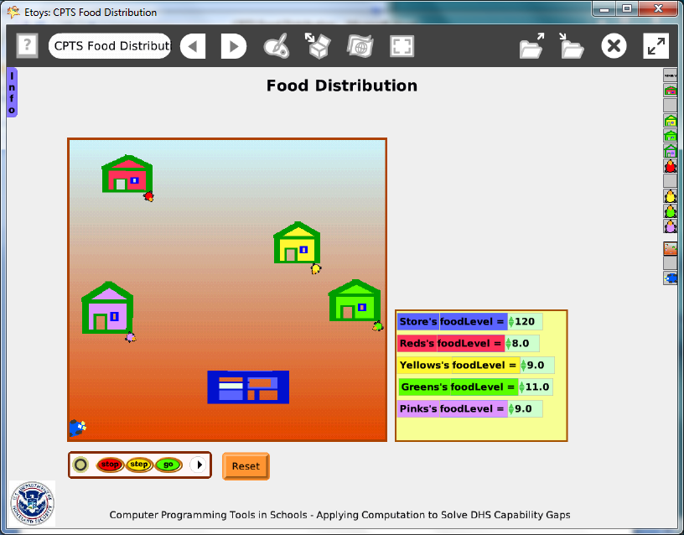

Time: Five 45 minute labs

Challenge: Design a food distribution network with houses, cars, a store and a truck that simulates a cycle of supply and demand.

Programming:
Basic script tiles, conditional statements, variables, constructed tiles, random number tiles, and watchers show that show changing data in real time, scripts that are ticking, paused, and normal.

Things you’ll need to know:
Playfields are in Supplies and used to contain the model in a small area. Its Viewer has a category of tiles to change colors and shading called fill and border.
The “turn toward” tile ends with the word “dot”. A “dot” indicates that the tile will accept the name of another object or location.

Quick Guides
- Paint Tools/ All
- Halo Handles/All
- Supplies: Text, All Scripts Tool, Add a New Flap
- Script Tiles: Forward by, Heading, X and Y Locations, Random Numbers, Two color Test, Scripting, Make a Script Tile
- Menus: Normal Ticking, Button Fires a Script, Watchers, Viewer Icons Set, Scriptor Icons Set

Things to think about:
- Why does this project use variables?
- Why does this project use random numbers?
- Is the range of the random number an important factor in making a balanced system that does not fail? What happens if random numbers are not used?

Extensions:
- Set the values of the variables to control whether demand is greater than supply or less than supply. Can you set the values so the system would run in balance forever? Can you set the values so the store is empty of food in less than 30 seconds, one minute, and two minutes?
- Experiment with adding more houses, more trucks, more stores, and shorter distances.
- Make three stores and three trucks, what is the most fuel efficient location of 15 houses? What happens to the fuel efficiency of the delivery trucks?

NETS for Students:
http://www.iste.org/standards/nets-for-students/nets-student-standards-2007.aspx
1. Creativity and Innovation: a, b, c, d
2. Communication and Collaboration: b
3. Research and Information Fluency: a, b, c, d
4. Critical Thinking, Problem Solving, and Decision Making: a, b, c, d
5. Digital Citizenship: a, b
6. Technology Operations and Concepts: a, b, c, d

CSTA:
CSTA Level II: Objectives and Outline
http://csta.acm.org/Curriculum/sub/CurrFiles/L2-Objectives-and-Outlines.pdf
Level II objectives for middle school students are furthered through studying a programming language well enough that the student is proficient with it. Whether the language is Etoys, StarLogo TNG, or Scratch, it is the ability to use the language to express ideas that is valuable. A student skillful enough to use any programming language to express ideas, solve problems, model behaviors, simulate data, or to educate or entertain is an entitled person in today’s society.
Topics of particular note are:
Topic 2: Problem Solving
Topic 6: Connections between Mathematics and Computer Science
Topic 11: Programming Languages
Topic 13: Multimedia

Common Core Standards Mathematics:
http://www.corestandards.org/the-standards/mathematics
6. NS.6, 6.EE.2
7. RP.1
8. F.4

Teacher Notes:
Materials:
Comments: These scripts use variables, conditional statements and scripting tiles. The project is not difficult but there are many scripts and many decisions all of which take time.
Start this project with the store and the truck because the house and car have scripts that use information about the store and the truck.

Objects - Scripts – Decisions
The behaviors of the truck, car, store, and house food consumption are scripted and each must be decided upon before scripting.

Example Scripts:

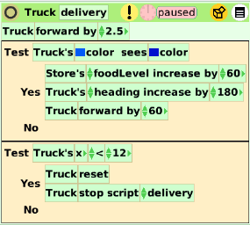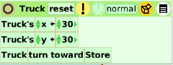

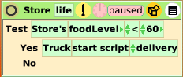

The yellow, pink, and green houses are copies of the red house and its scripts so all are the same.
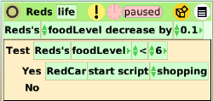
The yellow, pink and green cars are copies of the red can and its scripts, so all are the same.
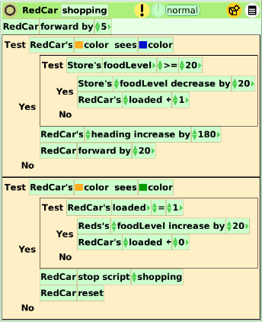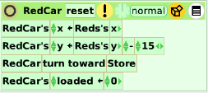
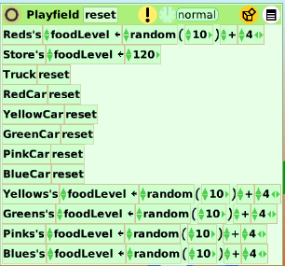

Student Notes:
Food Distribution Investigation: Observations Name_______________________
This applet shows a community that shares a grocery store. A household goes to the grocery store, picks up some food and returns home.
Click Go and just watch for 60 seconds. Hit “stop” and then “reset”.
1) Make three observations about what you think is happening.
a)

b)

c)

2) Read the questions below and then start the applet again. When you think you know the answer to a question hit “pause” and answer it, then hit “go”
- When does a car leave the house to go shopping?

- How much food does the delivery truck deliver each time?

c) How does the delivery truck know when to deliver food?

- Do any of the houses ever run out of food? If so, which one(s) and why do you think this is?

- Can the grocery store ever run out of food? If so, how could you avoid
this?

f) Which house would you like to live in and why?

